Abstract:
This report presents an analysis of a two-dimensional truss structure to determine the reaction forces at various supports and the internal forces within the members. The analysis was conducted using both theoretical methods, specifically the method of joints and sections, and through computational simulation using ANSYS and SolidWorks software. The truss was subjected to different support conditions and external loads to simulate real-world scenarios.
The theoretical analysis provided initial insights into the expected behavior of the truss under the applied loads. ANSYS or SolidWorks simulation was then employed to obtain more precise results, which were compared with the theoretical calculations. Discrepancies between the two sets of results were analyzed to understand the limitations of the theoretical approach and the accuracy of the computational simulation.

Keywords: ANSYS, SolidWorks, trusses, structural configuration, Members, Reaction Forces, Support reactions, Distributed Loads, Static equilibrium.

- Truss:
A truss is an assemblage of members (such as beams) forming a rigid framework [1]. A truss is a fundamental structural element used to provide support and stability to structures such as bridges, roofs, and towers etc. A truss typically consists of interconnected members that work collectively by distributing the applied loads along the members’ axis to ensure stability [2]. The truss structure is entirely made up of two-force members. Some of the most common are the types of trusses are:
- Pratt
- Howe
- Warren
- Modified Warren.
The truss pattern refers to the arrangement of internal vertical and diagonal members [3].

- Parts of a Truss:
A truss is composed of:
- Joints
- Members
- External Forces (reaction forces and applied forces).

Joints: The joints are often labelled with a letter and are where the external forces and members connect.
Members: Members are metal or wooden beams labelled with the connection between joints.
External Forces: The external forces are the reaction forces and the applied forces. The applied forces come from the load distributed across the bridge or from the roof [4].

- Two force members:
A two-force member is a body that has forces acting on it in only two locations. In order to have a two-force member in static equilibrium, the net force at each location must be equal, opposite, and collinear [5].

- Compression and tension forces in members:
A truss member can only support a force along its axis, which would either pull or push on it. If the member is being pulled, it is said to be in tension, and if it is being pushed, it is said to be in compression. Tension members are held straight by means of tensile loads, while in compression members, the compressive loads tend to bend the member out of the plane of loading. One standard sign convention is to assume all members are in tension, labelled as positive (+), then any negative number (-) means the member is in compression [6,7].

- Distributed Loads:
Distributed loads can be defined as forces divided or spread over length, volume, or area. Distributed load is a force per unit length. or force per unit area depicted with a series of force vectors joined together at the top. Distributed loads may be any geometric shape or defined by a mathematical function. The distributed loads are treated as the weight of the members; that is, the total load on each of the upper members is replaced by a vertical force, half applied to the joint at each end of the member [8].
The magnitude of the distributed load is the total load divided by the length over which it spreads. So,

ഡ = ∑ Wi / ℓ

Here, “ഡ” is the distributed load, “Wi” is the total load and “ℓ” is the length over which it is spread or distributed [9].

- Reaction Forces:
The newton’s third law states that to every action there is an equal and opposite reaction. Reactions are forces developed at the support of a structure, to keep the structure in equilibrium. To find the reaction forces on the truss it is required to use the equations for static equilibrium of the truss keeping in consideration all the loads/forces acting on it. These reaction forces are produced in the members due to the applied external loads on the truss [10].

- Static Equilibrium of a Truss:
Static equilibrium refers to the physical state in which a system’s components are at rest and the net force is zero through the system. Static equilibrium takes place when all the forces acting on an object are balanced, and the object is not in motion in relation to the relative plane [11].
In a 2D system exhibiting static equilibrium, we can say that:
∑Fx = ∑ Fy = 0
∑Mx = ∑My = 0

- Supports in a Truss:
The reaction forces produced at any node of the truss may depend on the type of support that truss has. Some major types of supports in a truss is given as follows:
1. Fixed Support:
A fixed support is the most rigid type of support or connection. It constrains the member in all translations and rotations (i.e., it cannot move or rotate in any direction. Since they restrain both rotation and translation, they are also known as rigid supports. This means a structure only needs one fixed support to be stable. All three equations of equilibrium can be satisfied [11,12].
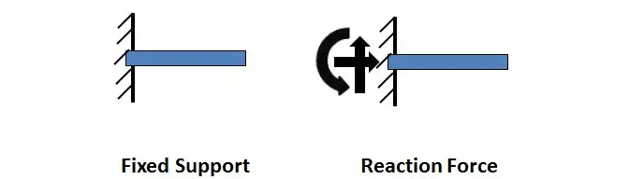Fig.01 “Fixed support and its reaction forces”

2. Pinned Support:
A pinned support allows rotation to occur but no translation (i.e., it resists horizontal and vertical forces but not a moment. It is also true that a pinned connection could allow rotation in only one direction; providing resistance to rotation in any other direction. [11,12]
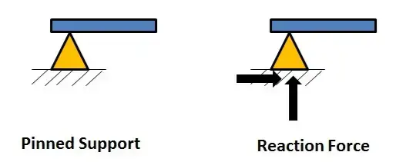Fig.02 “Pinned support and its reaction forces”

3. Roller Support:
Roller supports are free to rotate and translate along the surface upon which the roller rests. The surface can be horizontal, vertical, or sloped at any angle. The resulting reaction force is always a single force that is perpendicular to, and away from, the surface. [11,12]
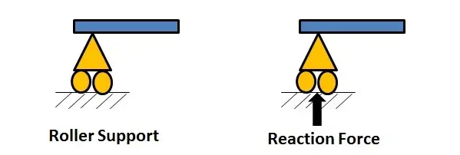Fig.03 “Roller support and its reaction forces”

- Explanation of Truss:
The truss under study for this report is given as:
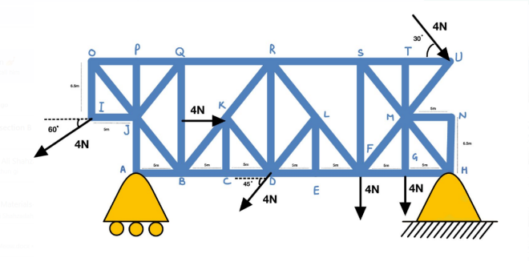Fig. 04 “A truss under study”

The above shown truss is supported by a roller at point A and pin at point H. The whole truss assembly also contains several zero force members that can be neglected while calculating the internal forces in the members. The free body diagram of the mentioned truss is given as follows:

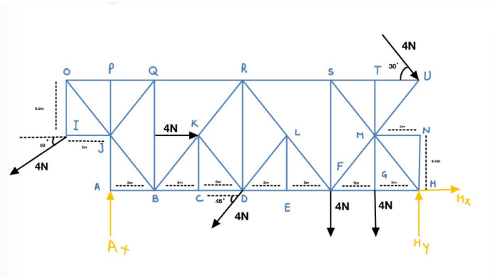
Fig. 05 “Free body diagram of truss under study”

The axis fixed for solving this truss are given as follows:
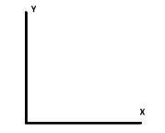

- Manual Solution of the Truss:
The two main techniques used for solving the truss are the methods of sections and methods of joints, each of which are explained below:

- Method of Sections:
The method involves cutting the truss into individual sections and analyzing each section as a separate rigid body. This method uses rigid body analysis to solve a specific member or two. [13]
- Method of Joints:
The Method of Joints involves drawing a free-body diagram of each joint in the structure, keeping in mind that each joint should be in equilibrium, hence, the sum of forces is zero. [14]

Now for the given Truss, solving for the external forces:

∑Fx = 0
4 + 4cos30 – 4cos45 – 4cos60 + Hx = 0
Hx = -2.6356 N

∑Fy = 0
-4sin30 – 4sin45 – 4 - 4 – 4sin60 +Ay + Hy = 0
Hy + Ay = 16.29253 N ---- (1)
Also, for the pin support at H, the sum of moments is given as :
∑Mx = 0
∑My = 0
Now, taking anticlockwise moment as positive:

(4x5) + (4x10) + (4sin45 x 20) + (Ay x 35) + (4sin60 x 40) + (4cos60 x 6.5) – (4 x 6.5) – (13x 4cos30) = 0

Ay = 5.631 N

Putting value of Ay in equation 1:
Hy + 5.631 = 16.29253

Hy = 10.661 N

- At Joint A:
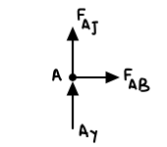
Σ F_{x} =0
F_{AB}=0
Σ F_{y} =0
F_{Aj}+ F_{Ay} =0
F_{Aj}= -F_{Ay}

- At Joint B:
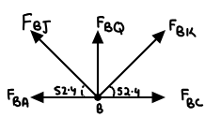
Σ F_{x} =0
-F_{BA} + F_{BC} -F_{BJ} ($\frac{5}{8.2006}$) +F_{BK} ($\frac{5}{8.2006}$)=0
F_{AB} =-F_{BA}=0
Σ F_{y} =0
F_{BQ}+ F_{BJ} ($\frac{6.5}{8.2006}$) +F_{BK} ($\frac{6.5}{8.2006}$) =0

- At Joint C:
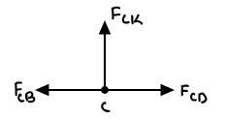
Σ F_{x} =0
-F_{CB}+ F_{CD} =0
F_{CD}= F_{CD}
Σ F_{y} =0
F_{CK}=0

- At Joint D:
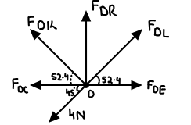
Σ F_{x} =0
F_{DE}- F_{DC} -F_{DK} ($\frac{5}{8.2006}$) +F_{DL} ($\frac{5}{8.2006}$)-4$\cos{45}$=0
Σ F_{y} =0
F_{DR}+ F_{DK} ($\frac{6.5}{8.2006}$) +F_{DL} ($\frac{6.5}{8.2006}$)-4$\sin{45}$ =0

- At Joint E:
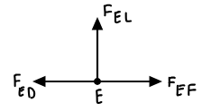
Σ F_{x} =0
-F_{ED}+ F_{EF} =0
F_{EF}= F_{ED}
Σ F_{y} =0
F_{EL}=0

- At Joint F:
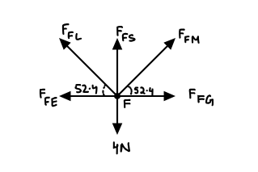
ΣF_{x} = 0
F_{FG} - F_{FE} - F_{FL}(cos52.4) + F_{FM}(cos52.4) = 0
ΣF_{y} = 0
F_{FS} – 4 + F_{FL}(sin52.4) + F_{FM}(sin52.4) = 0
- At Joint G:
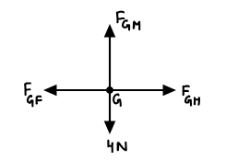
ΣF_{x} = 0
F_{GH} – F_{GF} = 0
F_{GH} = F_{GF}
ΣF_{y} = 0
F_{GM} = 4N
- At Joint H:
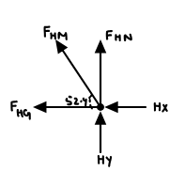
ΣF_{x} = 0
2.6356 + F_{HG} +F_{HM} (cos52.4) = 0
ΣF_{y} = 0
F_{HN} + F_{NM} (sin52.4) + H_{Y} = 0
- At Joint I:
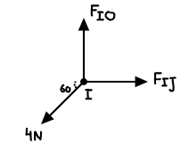
ΣF_{x} = 0
F_{IJ} – 4cos(60) = 0
F_{IJ} = 4cos(60)
F_{IJ} = 2 N
ΣF_{y} = 0
F_{IO} – 4sin60 = 0
F_{IO} = 4sin60
F_{IO} = 3.46 N
- At Joint J:
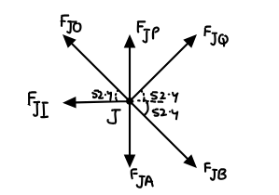
ΣF_{x} = 0
F_{JQ} (cos52.4) + F_{JB} (cos52.4) – F_{JO} (cos52.4) = 2
ΣF_{y} = 0
F_{JQ} (sin52.4) - F_{JB} (sin52.4) +F_{JO} (sin52.4) = 2

- At Joint K :
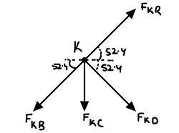
∑ Fx = 0
FKR (Cos (52.4)) + FKD (Cos (52.4)) + FKB (Cos (52.4)) + 4 = 0
∑ Fy = 0
FKR (Sin (52.4)) - FKC - FKB (Sin (52.4)) - FKD (Sin (52.4)) = 0
- At Joint L :
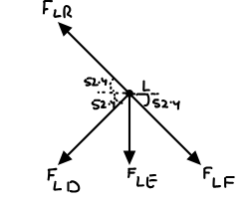
∑ Fx = 0
FLF (Cos (52.4)) - FLD (Cos (52.4)) - FLR (Cos (52.4)) = 0
∑ Fy = 0
FLR (Sin (52.4)) - FLE - FLD (Sin (52.4)) - FLF (Sin (52.4)) = 0
- At Joint M :
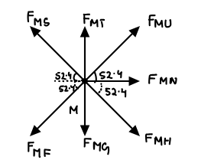
∑ Fx = 0
FMU (Cos (52.4)) + FMM (Cos (52.4)) + FMN - FMF(Cos (52.4))- FMS (Cos (52.4)) = 0
∑ Fy = 0
FMU (Sin (52.4)) + FMT - FMG - FMM (Sin (52.4)) - FMF (Sin (52.4))+ FMS (Sin (52.4)) = 0

- At Joint N :
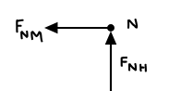
∑ Fx = 0
FNM = 0
∑ Fy = 0
FNH = 0
- At Joint O :
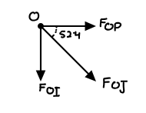
∑ Fx = 0
FDE - FDC - FDK($\frac{5}{8.2006})$ + FDL($\frac{5}{8.2006})$ -4(Cos(45)) = 0
∑ Fy = 0
FDL($\frac{6.5}{8.2006})$ + FDK($\frac{6.5}{8.2006})$ + FDR - 4 (Sin (45)) = 0

- At Joint P :
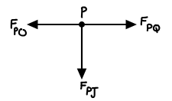
Σ F_{x} = 0
F_{PQ} = F_{PO}
Σ F_{y} = 0
F_{PJ} = 0

- At Joint Q:
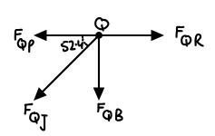
Σ F_{x} = 0
F_{QR} – F_{QP} – F_{QJ} cos 52.4 =0
Σ F_{y} = 0
-F_{QB}-F_{QJ} sin 52.4=0
F_{QJ} sin 52.4 = F_{QB} = 0

- At Joint R:
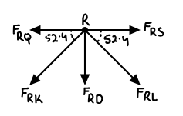
Σ F_{x} = 0
F_{RS}-F_{RQ}+F_{RL}-F cos52.4=0
Σ F_{y}= 0
-F_{RD}-F_{RK} sin 52.4 -F_{RL} sin 52.4=0
F_{RD}+F_{RK} sin 52.4 +F_{RL} sin 52.4=0

- At Joint S :
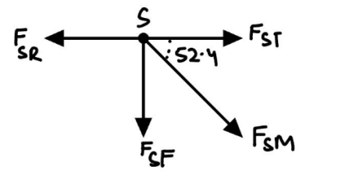
Σ F_{x} = 0
F_{ST}-F_{SR}+F_{SM} cos 52.4=0
Σ F_{y} = 0
-F_{SF}-F_{SM} sin 52.4=0
F_{SF} = F_{SM} sin 52.4

- At Joint T:
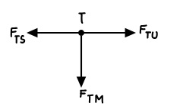
Σ F_{x} = 0
F_{TU}-F_{TS}=0
F_{TU} = F_{TS}
Σ F_{y} = 0
F_{TM} = 0

- At Joint U:
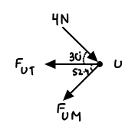
Σ F_{x} = 0
4cos30 – F_{UT} – F_{UM} cos 52.4 =0
F_{UT} = 4cos30 – (-2.52439)cos52.4
F_{UT} = 5.0043
Σ F_{y} = 0
-4sin 30 – F_{UM} sin52.4 =0
F_{UM} = -2.52439

By plugging in the values to find the force members of the truss , we get:
F_{AB} = 0 N
F_{AJ} = -5.631 N
F_{RC = 0} N
F_{GM} = 4 N
F_{HM = - 13.4559 N}
F_{PJ = 0 N}
F_{UT} = 5.0043 N
F_{UM = - 2.5243 N}
F_{EL = 0 N}
F_{SM = - 10.9315 N}
F_{FS = - 8.6609 N}
F_{NH = 0 N}
F_{NM = 0 N}
F_{ST = 5.0043 N}
F_{TM = 0 N}
F_{IJ} = 2 N
F_{IO = 3.4641 N}
F_{OJ = - 4.7323 N}
F_{OP = 2.66773 N}
F_{PQ = 2.66773 N}
F_{MF = - 5.0486 N}
F_{JB = - 2.73495 N}
F_{QB = - 1.299797 N}
F_{QR = 3.6687 N}
F_{FL = - 0.834 N}
F_{HG = 5.5744 N}
F_{FG = 5.5744 N}
F_{FE = 6.414 N}
F_{ED = 6.414 N}
F_{BK = 1.09434 N}
F_{BC = 1.46074 N}
F_{CD = 1.46074 N}

- Introduction to the ANSYS Software:

Ansys is an analysis software that provides its users with an understanding of how their product will work or not work in real conditions. It is also called engineering simulation software and FEA or finite element analysis software. It performs advanced engineering simulations accurately, leaving room for less error. It optimizes various features like geometrical design, boundary conditions, etc. It runs multiple solver technologies, giving fast solutions. One of the most important advantages of Ansys is it resembles the real-world conditions where the product will be used.
Following attached data shows the interface of the software and its use to analyze the forces in the truss under study:

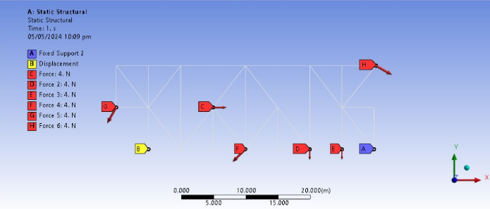
“Truss under the effect of Applied External Loads”

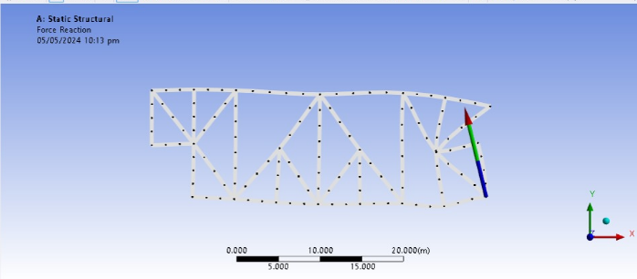
“Reaction Force due to Pin Support”

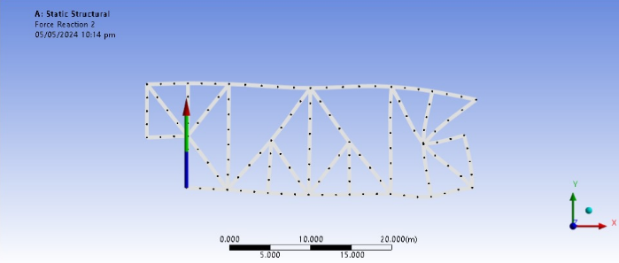
“Reaction due to Roller Support”

The simulation from the software was also used to calculate the force in each member of the truss. This was done to compare the values calculated manually and values determined by the software. Some force members are demonstrated as follows:

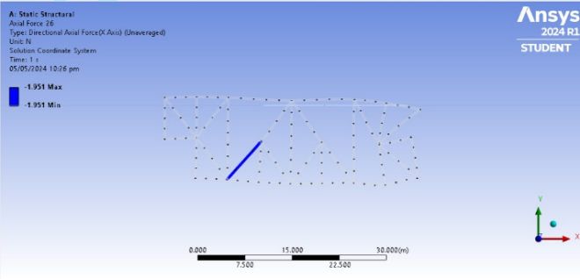
“Force in member BK”

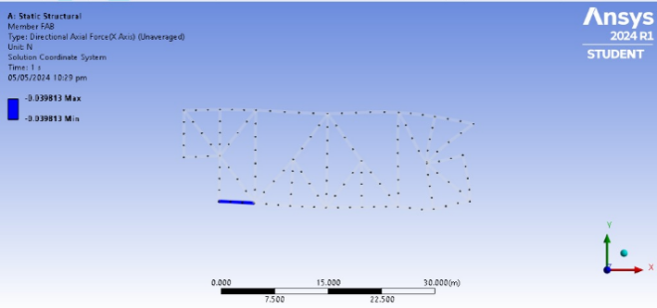
“Force in member AB”

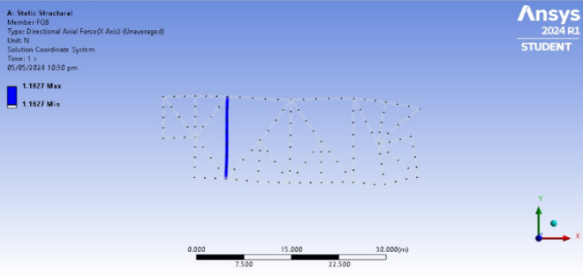
“Force in member QB”

The software determined the values of forces in members are given as follows:
-0.039813 = AB
1.5961= BC
1.5612= CD
2.3498 =DE
2.3114 =EF
2.2329 =FG
2.6924= GH
-0.80422= HN
0.15342 =NM
-10.007 =MH
0.83947= MG
-2.47= MU
-0.070969= MT
4.0161 =TS
6.1883 =SF
-1.3022 =SR
1.5243 =RQ
2.5128 =QP
2.4526 =PO
3.1949 =OI
1.8446 =IJ
-5.3357 =JA
0.74861= JB
-1.538 =JQ
1.1827 =QB
-1.951 =BK
-5.1589 =KR
-2.826 =KD
-0.19361= KC
4.5964 =DR
0.46124 =DL
-0.23615 =LE
-0.50581 =LF
-0.54126 =LR
-8.1657 =SM

- Deviations of Force values:
By comparing the forces determined the values determined by the software and by manual calculations , we get the following percentage errors:
For support reactions:

Percentage Error = [(Simulation Value – Manual Value) / Simulation Value] *100

For Hy:
Percentage Error = [(10.968 – 10.661) / 10.968] *100
Percentage Error = 2.799%
Similarly, for:
Ay:
Percentage Error = 5.75%
Hx:
Percentage Error = 0.0037%

The percentage errors for all the force members can also be calculated in a similar manner.

Some of the reasons that might have caused the deviation of the calculated forces from that given by the software include:
- Application of external forces may cause the truss to deform, resulting in discrepancies of the determined values.
- Theoretical calculations rely on simplifying assumptions about the behavior of the structure, which may not fully capture the complexities of the real-world system as done by the software.
- The accuracy of material properties (such as Young's modulus, Poisson's ratio) assumed in the theoretical calculations may differ from the actual properties used in the software simulation.

- References:

- https://www.merriam-webster.com/dictionary/truss
- https://www.engineeringskills.com/posts/what-is-a-truss
- https://pressbooks.library.upei.ca/statics/chapter/trusses-introduction/
- https://eng.libretexts.org/Bookshelves/Mechanical_Engineering/Mechanics_Map_(Moore_et_al.)/05%3A_Engineering_Structures/5.02%3A_Two-Force_Members#:~:text=A%20two%2Dforce%20member%20is,equal%2C%20opposite%2C%20and%20collinear.
- https://www.ae.msstate.edu/vlsm/truss/other_faq/ofaq.htm#:~:text=A%20truss%20member%20can%20only,said%20to%20be%20in%20compression.
- https://sciencedirect.com/topics/engineering/tension-member#:~:text=The%20two%20main%20differences%20between%20tension%20and%20compression%20members%20are%3A&text=Tension%20members%20are%20held%20straight,of%20the%20plane%20of%20loading.
- https://www.physicsforums.com/threads/roof-truss-distributed-load.958064/#:~:text=Treat%20the%20distributed%20load%20as,each%20end%20of%20the%20member.
- https://engineeringstatics.org/distributed-loads.html#:~:text=Distributed%20loads%20are%20forces%20which,commonly%20used%20for%20distributed%20loads.
- https://www.teachengineering.org/lessons/view/ind-2472-analysis-forces-truss-bridge-lesson#:~:text=Reactions%20are%20forces%20developed%20at,of%20the%20end%20bottom%20nodes.
- https://www.toppr.com/guides/physics/mechanics/static-equilibrium-definition-and-equation
- https://skyciv.com/docs/tutorials/beam-tutorials/types-of-supports-in-structural-analysis/#:~:text=1.,pole%20or%20column%20in%20concrete.
- ttps://web.mit.edu/4.441/1_lectures/1_lecture13/1_lecture13.html
- http://mechanicsmap.psu.edu/websites/5_structures/5-4_method_of_sections/methodofsections.html#:~:text=The%20method%20of%20sections%20is,as%20a%20separate%20rigid%20body.
- https://www.vaia.com/en-us/explanations/engineering/solid-mechanics/method-of-joints/#:~:text=The%20Method%20of%20Joints%20involves%20drawing%20a%20free%2Dbody%20diagram,equilibrium%20equations%20to%20find%20them.

